Tour code: Hatyai-Betong 5day4night (HBT-05)
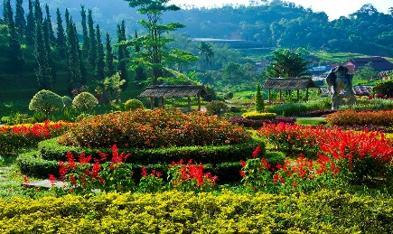
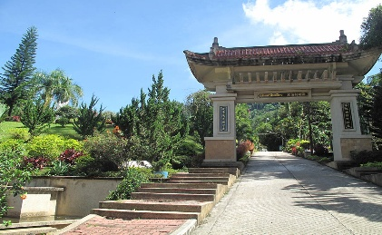


DAY 01 Flight arrive to Hatyai (meal by own)
Assemble at airport for flight to Hatyai , meet and great and transfer hotel check in ,
- Free time for shopping at Greenway Night Market

DAY 02 Hatyai - Betong (Breakfast / L/D)
- Breakfast at hotel restaurant
- Depart for Betong (approx..4 hours -250 km)
- Visit Betong Mongkhonrit Tunnel — Thailand’s first road tunnel
- Visit Betong Clock Tower & city center
- Explore Betong Night Market or walk around town
- Transfer back to Hotel for check-In

DAY 03 Betong Nature & Culture (Breakfast/L/D)
Early Morning
- Depart 5:00 AM to Aiyerweng Skywalk & Sea of Mist Viewpoint 🌄
→ Enjoy sunrise above the clouds
- Coffee and light breakfast at the viewpoint
- Return to hotel for rest and full breakfast
- Visit Winter Flower Garden or Betong Hot Spring

DAY 04 Betong-Hatyai (Breakfast/L/D)
- Breakfast at hotel, check out
- Stop by Piyamit Tunnel & Peace Museum (historic attraction)
- Visit 3-Culture Arch Gate (Gerbang 3 Budaya) for photo stop
- Depart Betong for Hat Yai (4 hrs drive)
- Check-In Hotel

DAY 04 Hatyai- Departure (Breakfast)
- Breakfast at hotel
- Free time for last-minute shopping or sightseeing
- Visit Wat Hat Yai Nai or Central Festival Mall
- Check out and transfer to Hat Yai Airport

